**Introduction To Computer Hardware**

**Computer hardware** includes the physical parts of a computer, such as the case, central processing unit  (CPU), monitor, mouse, keyboard, computer data storage, graphics card, sound card, speakers and motherboard.

By contrast, software is the set of instructions that can be stored and run by hardware. Hardware is so-termed because it is "hard" or rigid with respect to changes, whereas software is "soft" because it is easy to change.

Hardware is typically directed by the software to execute any command or instruction. A combination of hardware and software forms a usable computing system, although other systems exist with only hardware.

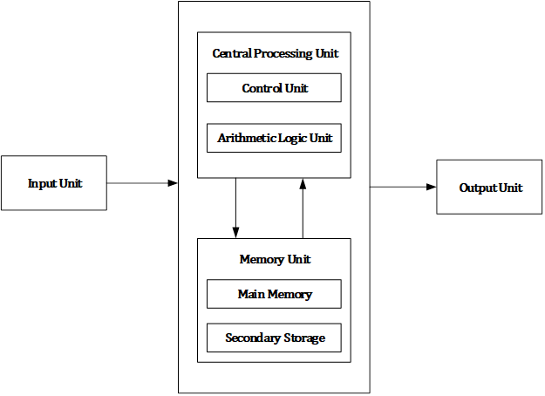

Computer hardware consists of different functional units: input unit, central

processing unit (CPU) which consists arithmetic logic unit (ALU) and control unit

(CU), memory unit and output unit.

**Major Components of Computer System**

1. **Mother Board**

The motherboard is at the center of what makes a PC work. It houses the CPU and is a hub that all other hardware runs through. The motherboard acts as a brain; allocating power where it’s needed, communicating with and coordinating across all other components – making it one of the most important pieces of hardware in a computer.

When choosing a motherboard, it’s important to check what hardware ports the motherboard supplies. It’s vital to check how many USB ports, and what grade (USB 2.0, 3.0, 3.1) they are, as well as what display ports are used (HDMI, DVI, RGB) and how many of each there are. The ports on the motherboard will also help you define what other hardware will be compatible with your computer, such as what type of RAM and graphics card you can use.

Although the motherboard is just one piece of circuitry, it is home to another one of the most important pieces of hardware: the processor.

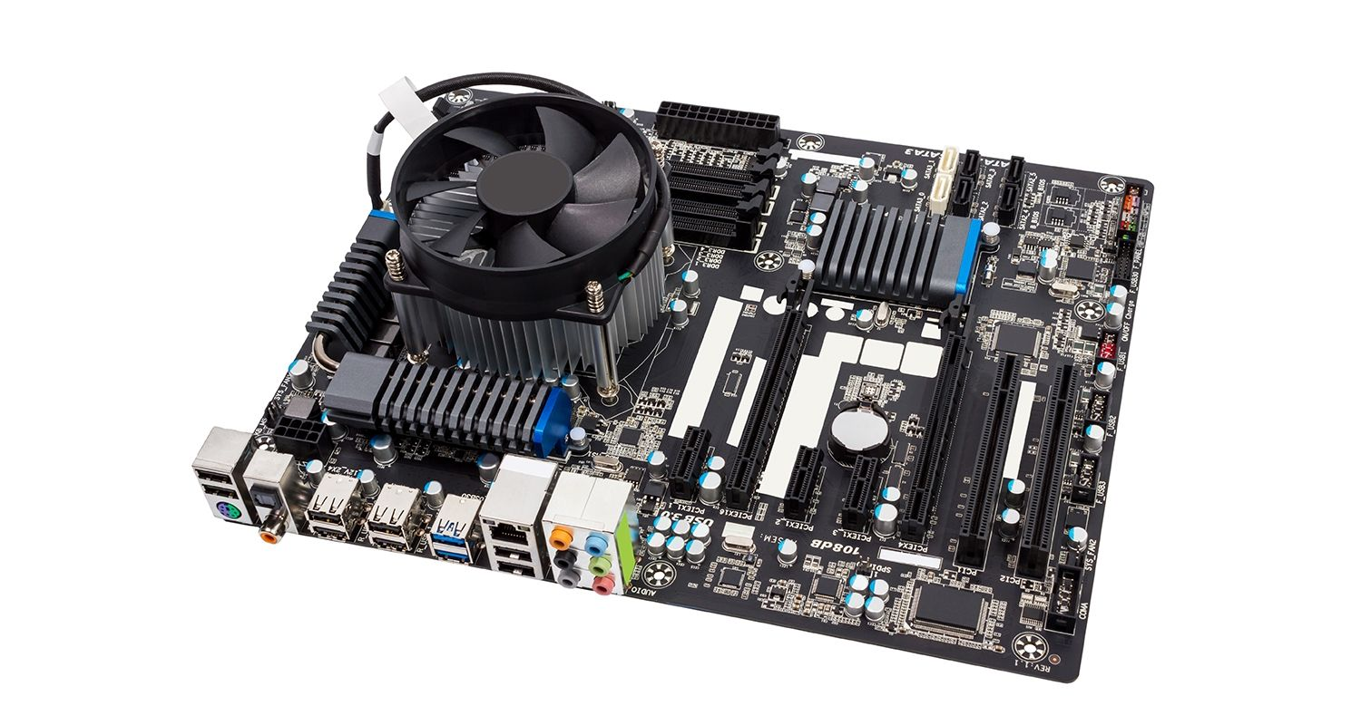

1. **Ram Modules**

In computing, a **memory module** or **RAM(random access module) stick** is a printed circuit board on which memory integrated circuits are mounted. Memory modules permit easy installation and replacement in electronic systems, especially computers such as personal computers, workstations and servers. The first memory modules were proprietary designs that were specific to a model of computer from a specific manufacturer. Later, memory modules were standardized by organizations such as JEDEC and could be used in any system designed to use them.

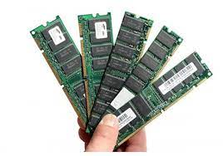

1. **Daughter Cards**

A daughter card or daughterboard is **a type of circuit board that gets added to an existing one**. Its name is appropriate for its use, since it is connected to a “motherboard” or “main board.” The motherboard is the primary circuit board for a device. It is usually in the device as it is shipped from the factory.

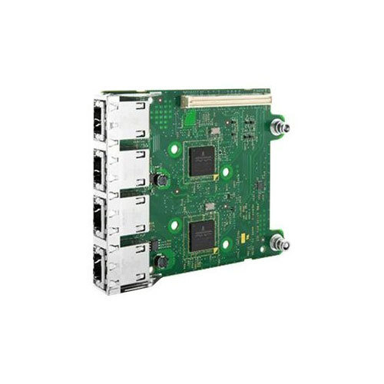

1. **Bus Slots**

In simple words, the computer buses are **electrical wires which connect the various hardware components in a computer system**. The computer bus carries the data, control signals, memory addresses and the power supply to these components.

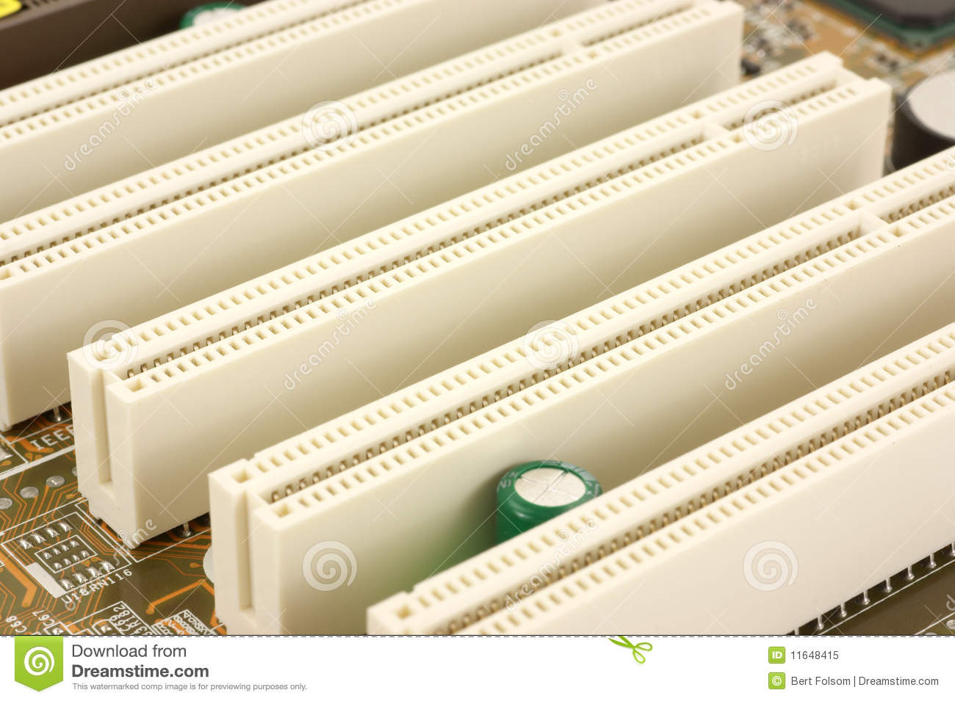

1. **SMPS**

The full form of SMPS is **Switched Mode Power Supply** also known as **Switching Mode Power Supply**. SMPS is an electronic power supply system that makes use of a switching regulator to transfer electrical power effectively. It is a PSU (power supply unit) and is usually used in computers to change the voltage to the appropriate range for the computer.

An SMPS adjusts output voltage and current between different electrical configurations by switching the basics of typically lossless storage such as capacitors and inductors. Ideal switching concepts determined by transistors controlled outside of their active state that have no resistance when ‘on’ and carry no current when ‘off.’ It is the idea why switches with an ideal function will operate with 100 per cent output, that is, all input energy is provided to the load; no power is wasted as dissipated heating. In fact, such ideal systems do not exist, which is why a switching power source cannot be 100 per cent proficient, but it is still a vital improvement in effectiveness over a linear regulator.

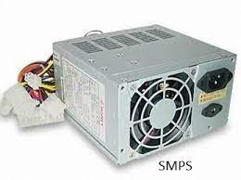

1. **Internal Storage Devices**

Most computers have some form of internal storage. The most common type of internal storage is the hard disk.

At the most basic level, internal storage is needed to hold the operating system so that the computer is able to access the input and output devices.

It will also be used to store the applications software that you use and more than likely, the original copies of your data files.

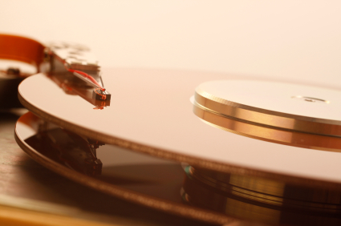

1. **Internal Ports**

A Computer Port is an interface or a point of connection between the computer and its peripheral devices. Some of the common peripherals are mouse, keyboard, monitor or display unit, printer, speaker, flash drive etc.

The main function of a computer port is to act as a point of attachment, where the cable from the peripheral can be plugged in and allows data to flow from and to the device.

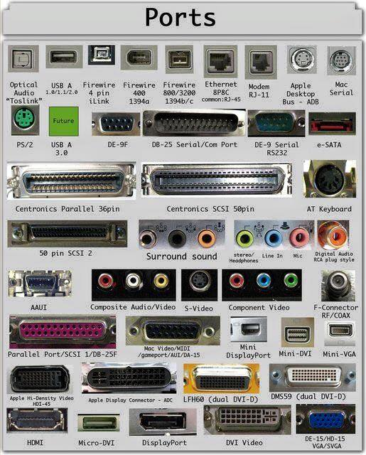

A computer port is also called as a Communication Port as it is responsible for communication between the computer and its peripheral device. Generally, the female end of the connector is referred to as a port and it usually sits on the motherboard.

In Computers, communication ports can be divided into two types based on the type or protocol used for communication. They are Serial Ports and Parallel Ports.

A serial port is an interface through which peripherals can be connected using a serial protocol which involves the transmission of data one bit at a time over a single communication line. The most common type of serial port is a D-Subminiature or a D-sub connector that carry RS-232 signals.

A parallel port, on the other hand, is an interface through which the communication between a computer and its peripheral device is in a parallel manner i.e. data is transferred in or out in parallel using more than one communication line or wire. Printer port is an example of parallel port.

1. **Specification of desktop and server class computers**

When multithreaded operating system processes are not available, a good alternative is to use a set of processes to emulate a pool of threads. That is, instead of having one multithreaded process, the system uses a set of single-threaded processes, all of which are running the same program (see Figure 2.8). This often is called a **server class**. In this case, for each server program, there is a set of server processes that runs it.

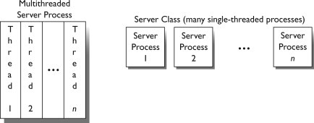

**PC Desktop Hardware Specifications**

* **Motherboard:** Gigabyte B560M-DS3H Motherboard
* **Power Supply:**Scaled appropriately to support delivered system with reasonable growth potential (In Win CE685 PC case with 300 watt 80PLUS certified power supply)
* **Case:**In Win CE685 PC case with 300 watt 80PLUS certified power supply
* **CPU:** Intel Core i5-11400 Processor
* **RAM:**8GB DDR4 2666 (PC4 21333) RAM (1 8GB DIMM)
* **NIC:**On-board 10/100/1000 Mbps based Ethernet NIC
* **HDD:** 250 GB Western Digital M.2 NVMe SSD Part # WDS250G2B0C
* **Video:**Integrated Intel HD Graphics with DVI Digital Output Interface
* **Optical Drive:** (optional)
* **Audio:** Onboard HD audio
* **Externally powered Satellite Speakers:**(optional)
* **6 External Powered USB Ports and 2 on front of case**
* **Operating System:**Microsoft Windows 7 Home Basic(or other least expensive Microsoft Windows operating system)
* **All appropriate cables necessary**
* **HIDs:** USB Optical mouse, mouse pad, USB keyboard, all necessary cables
* **3 year parts and labor warranty on all components**
* **Monitor:** 20″ Wide Screen LCD Monitor (1920×1080 native resolution) with DVI Digital Input Interface

**PC Laptop Specifications**

There is currently 1 laptop model specified for new purchases

* Intel Core i5-1135G7 Processor
* 8GB DDR4 2666 RAM
* 250 GB M.2 NVMe Solid State Drive
* 15.6″ Wide Screen Display
* Microsoft Windows Windows 7 Pro(or other least expensive Microsoft Windows operating system)
* On board 10/100/1000 Mbps Ethernet NIC
* On board Wireless NIC
* On board HD Audio
* 2 External powered USB Ports
* Padded Carry Case appropriate for delivered model
* Appropriate American Power Conversions Notebook Surge Suppressor for delivered model
* All appropriate cables necessary
* 3 year parts and labor warranty on all components